Stance Detection from Text
User Manual
- Install the application by following the steps mentioned in the Installation manual.
- After installation, run the server. Go to the url of the running app.
- You shall see the landing page
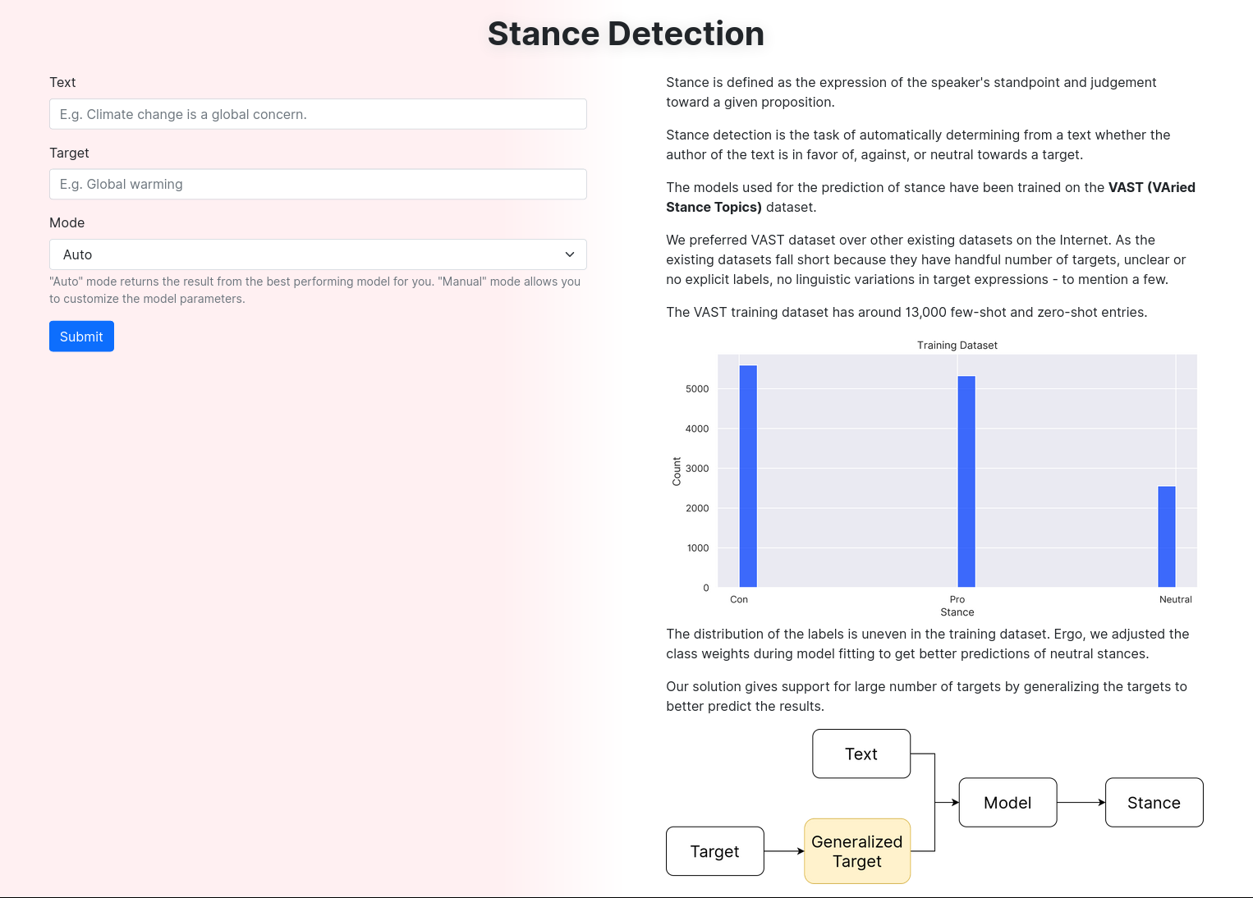
- Input a text and a target, using “auto” mode, submit the form. This shall give you set of the detected stances from different models for the pair of text and target. The bar shows the confidence and stance is mentioned at the center of the dial.
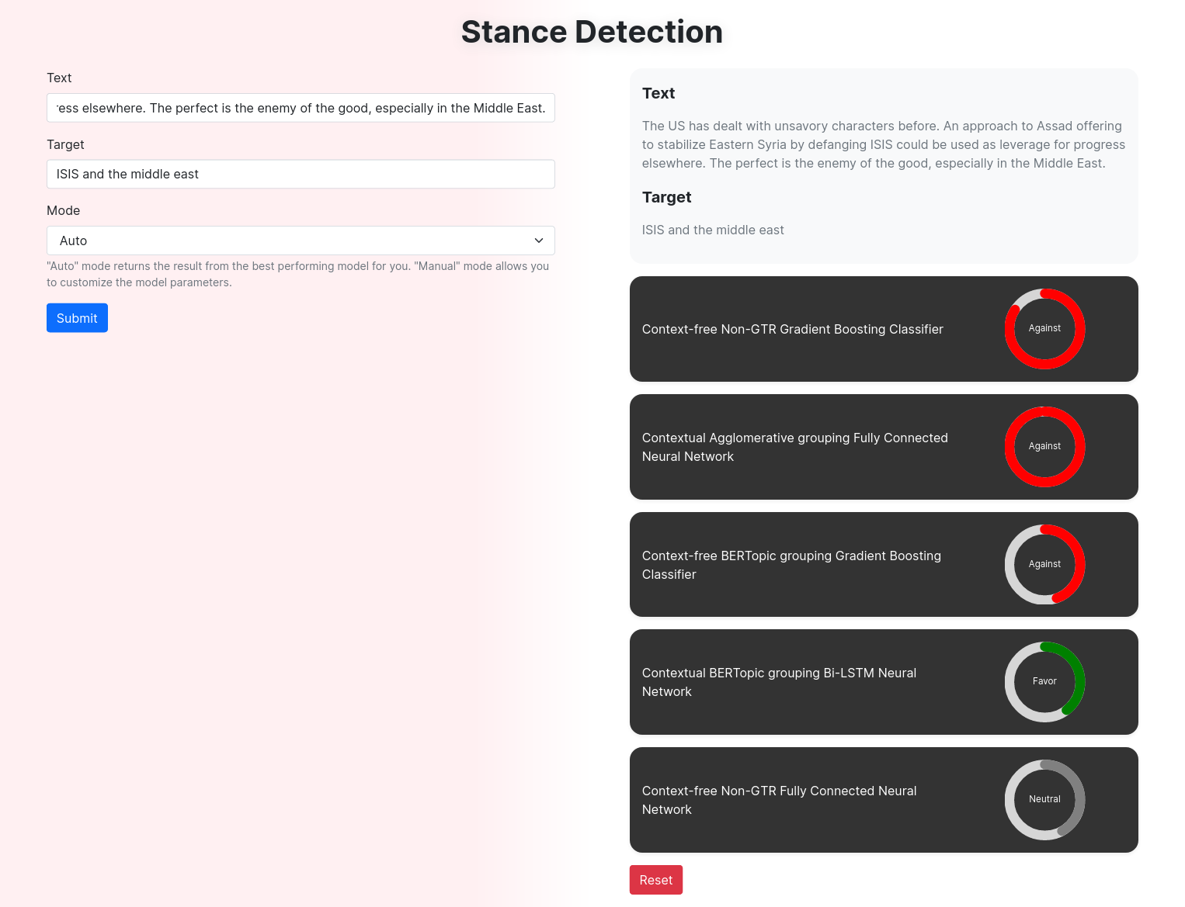
- In case of manual mode, you can customized the model options
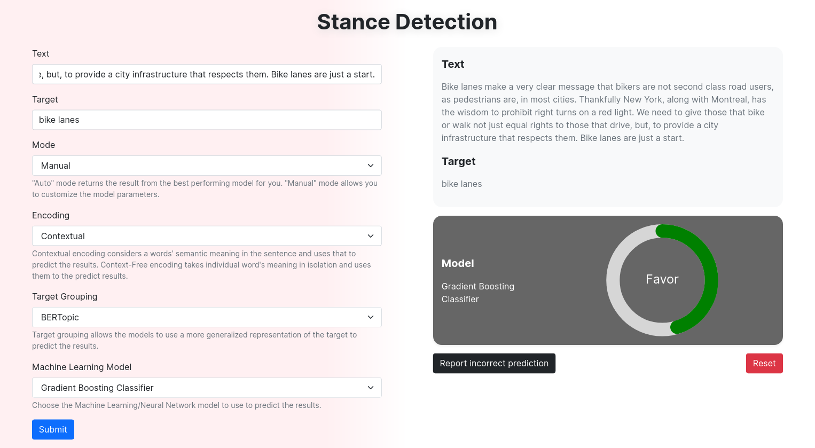
- Incorrect predictions can be report using the report incorrect prediction button
